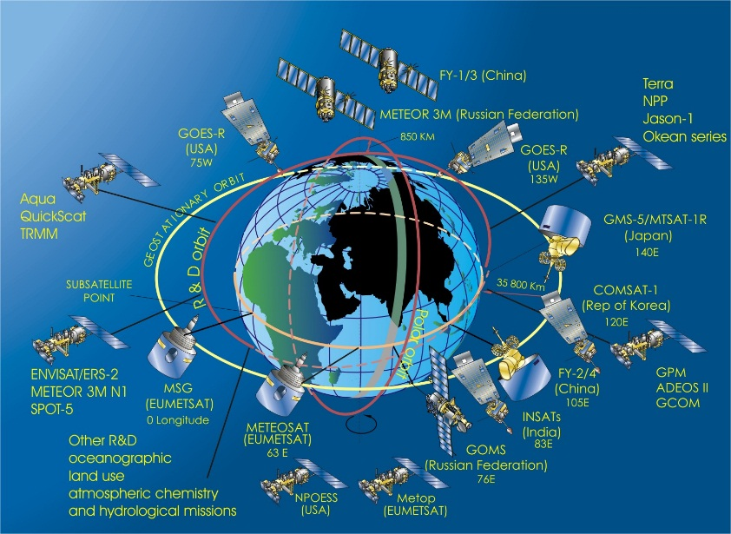

Think of the force acting on the objects

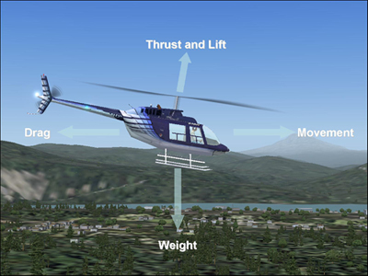 Think action-reaction
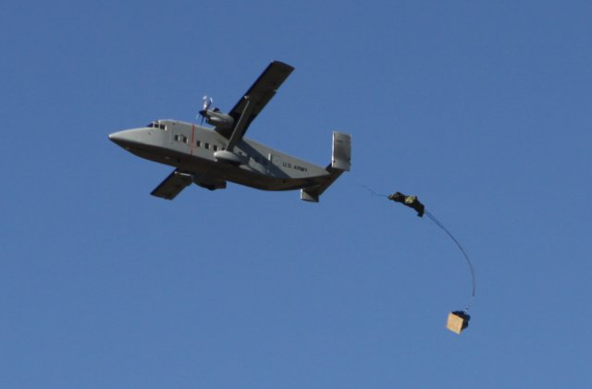 Think about about the force that is used to get the suppiles to remote areas
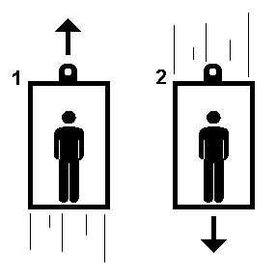Think about how an elevators controls what force

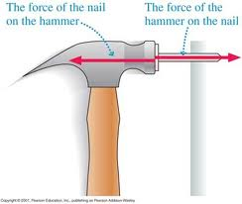think action-reaction
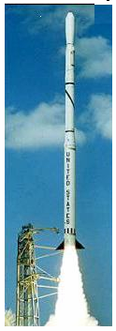think action-reaction
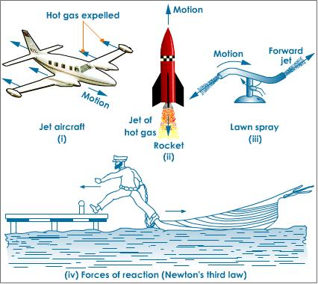
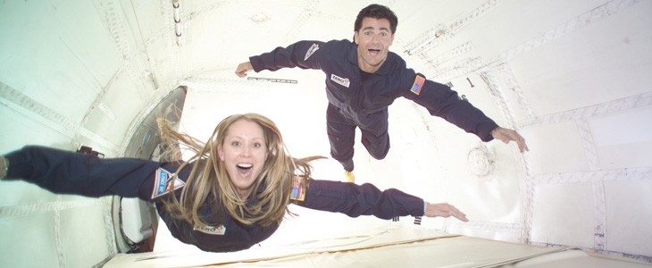 what force is not present, but are all the laws working?
Examples in Nature
Seeds/ pollen falling from bees or plants

Jumping

Meteorites

Diving

Plant growing or roots growing

Planets orbit around the sun

Goalie blocking a ball

Moon orbit around the Earth

