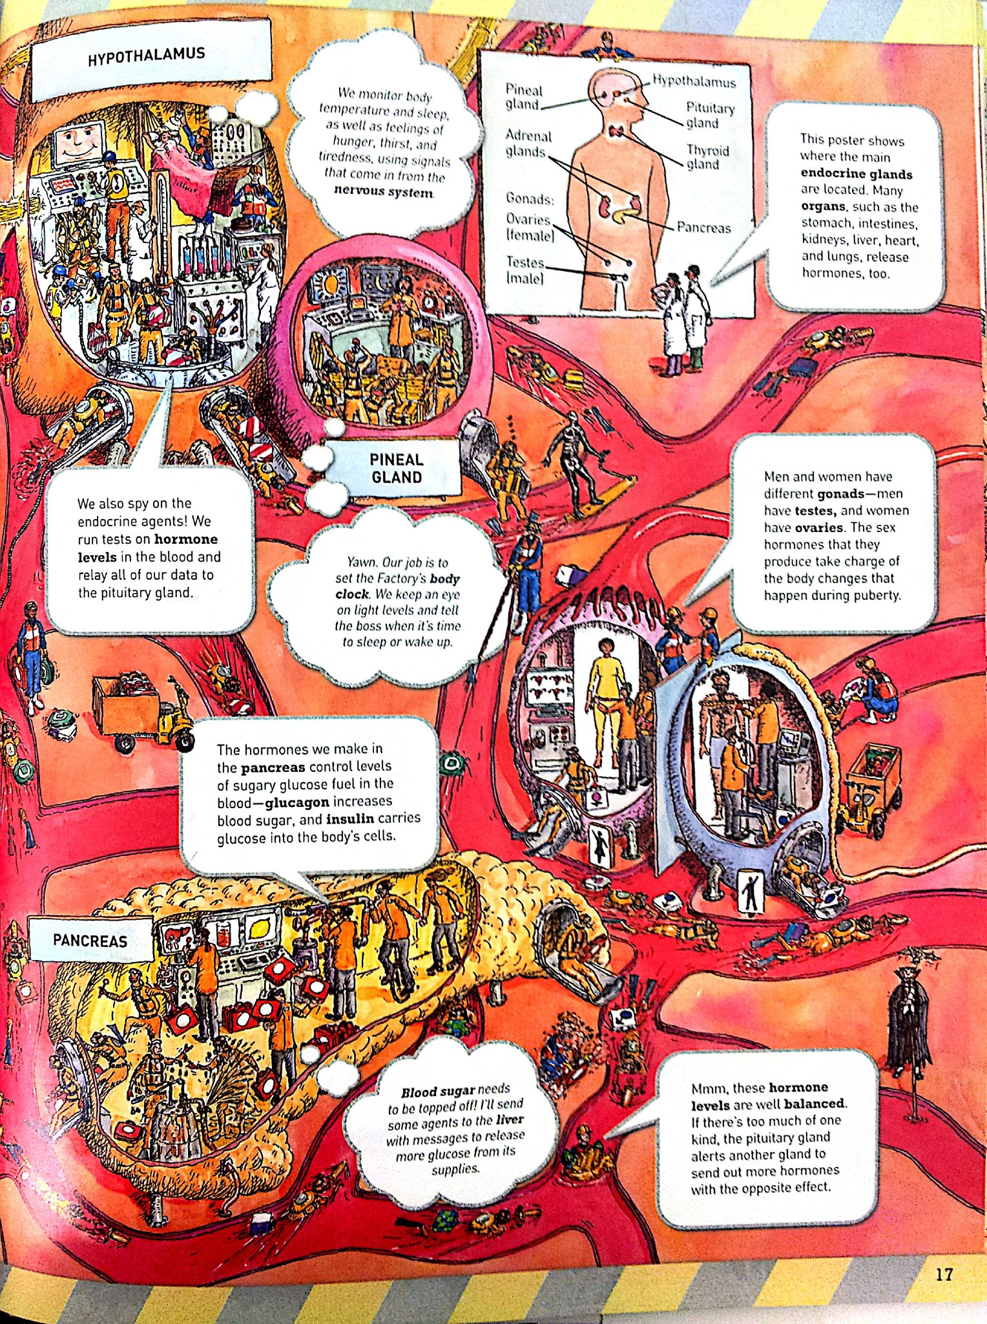
Generated by CamScanner from intsig.com Generated by CamScanner from intsig.com

